**Practical No. 09 Submission Date:**

**Title: Metropolis-Hasting and Gibbs sampling**

**Name: Rushikesh Rahul Sonawane**

**Roll no. 2002874**

**Q.1] Simulate a sample from BETA (2.7,6.3)(Target) ,where Proposal is**

**U(0,1), by using Metropolis-Hasting method**.

**Algorithm:**

1.let f(X) be the target density, q(X*|Xi) be the proposal distribution

2. Select an initial value X0, sample u U(0,1)

3. For i=1, 2,….,m repeat :

a) Draw candidate X* q(X*|Xi)

b) alpha A=MIN 1,(fX*) q(Xi|X*) f(Xi) q(X*|Xi)

c) If u<A set Xi+1=X*

o.w Xi+1=Xi

**Program:**

n = 10000 #Sample size

x = c() # to store values coming from target

y = c() # to store values coming from proposal

x[1]=0.5 # initial value

for (i in 1:n)

{

y[i]=runif(1,0,1)

u=runif(1,0,1)

r= min(dbeta(y[i],2.7,6.3)/dbeta(x[i],2.7,6.3),1)

x[i+1]=ifelse(u<=r,y[i],x[i])

}

x=x[5001:n]

hist(x,freq=FALSE)

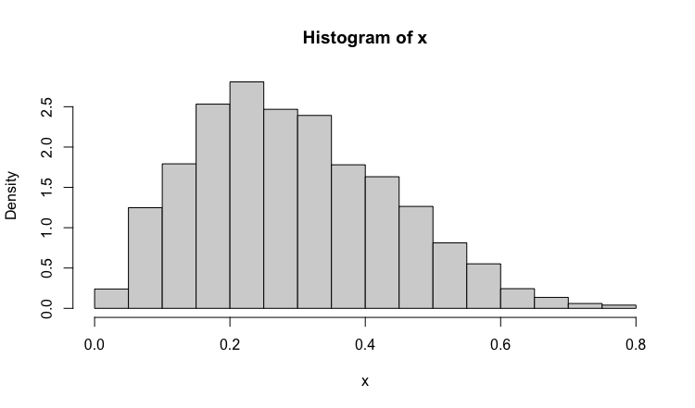

hist(rbeta(5000,2.7,6.3),freq=FALSE,add=T,col = "red")

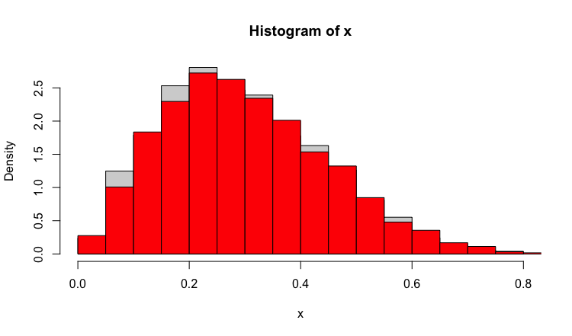

#To check whether both sample coming from same distribution or not

ks.test(jitter(x),rbeta(5000,2.7,6.3))

Two-sample Kolmogorov-Smirnov test

data: jitter(x) and rbeta(5000, 2.7, 6.3)

D = 0.0274, p-value = 0.04686

alternative hypothesis: two-sided

**H0 : Target Density and Density by Metropolis Hasting are same.**

**H1 : Target Density and by density Metropolis Hasting are different.**

**Here, P-value > 0.01 We accept H0.**

**Q.2] Simulate samples from exp(1) if proposal distribution is N(1,0) by using metropolis hasting method.**

**Program:**

**#Q2)**

target=function(x)

{

ifelse(x<0,return(0),return(exp(-x)))

}

X=rep(0,1000)

X[1]=3 #this is just a starting value

for(i in 2:1000)

{

currentx=X[i-1] #to store value coming from target distribution

proposedx=currentx+rnorm(1,mean=0,sd=1) # to store value coming from proposal dist

rho=min(target(proposedx)/target(currentx),1) # alpha quantity

if(runif(1)<rho)

X[i]=proposedx # ACCEPT MOVE

else{

X[i]=currentx #otherwise reject move, stay where we are

}

}

hist(X)

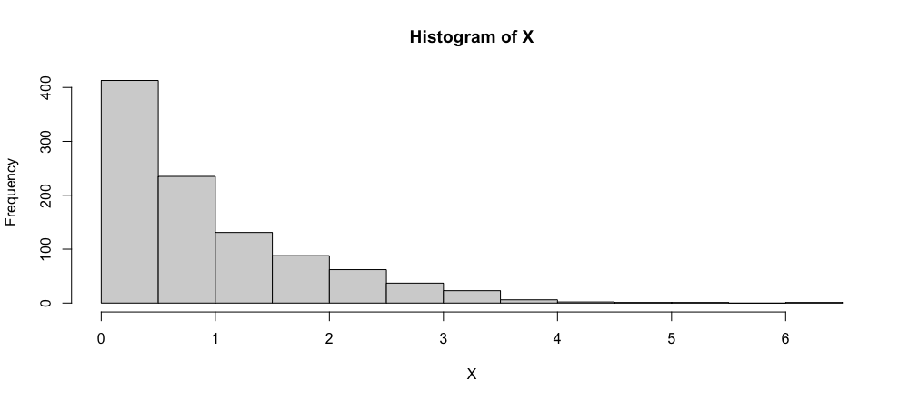

x1=rexp(1000,1)

hist(x1,add=T,col="red")

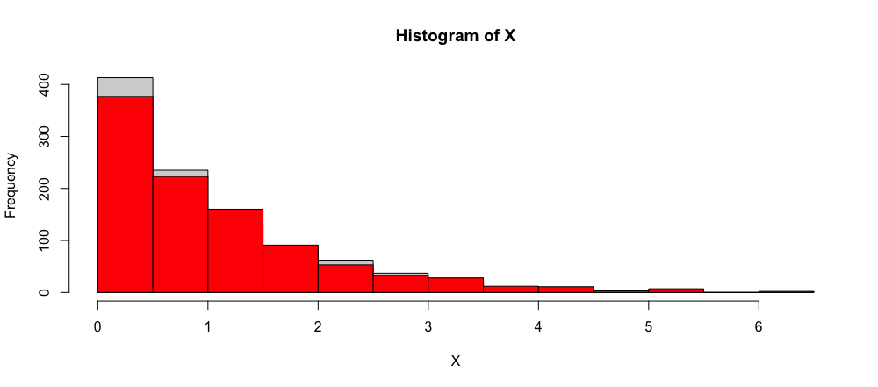

ks.test(jitter(X),x1)

Two-sample Kolmogorov-Smirnov test

data: jitter(X) and x1

D = 0.045, p-value = 0.2634

alternative hypothesis: two-sided

**H0 : Target Density and Density by Metropolis Hasting are same.**

**H1 : Target Density and by density Metropolis Hasting are different.**

**Here, P-value > 0.01 We accept H0.**

**Q.3]**  Let (X,Y) follows BVN (0, $\left(\begin{matrix}1 & ρ \\ ρ & 1\end{matrix}\right)$) .

Simulate samples from this distribution using Gibbs sample.

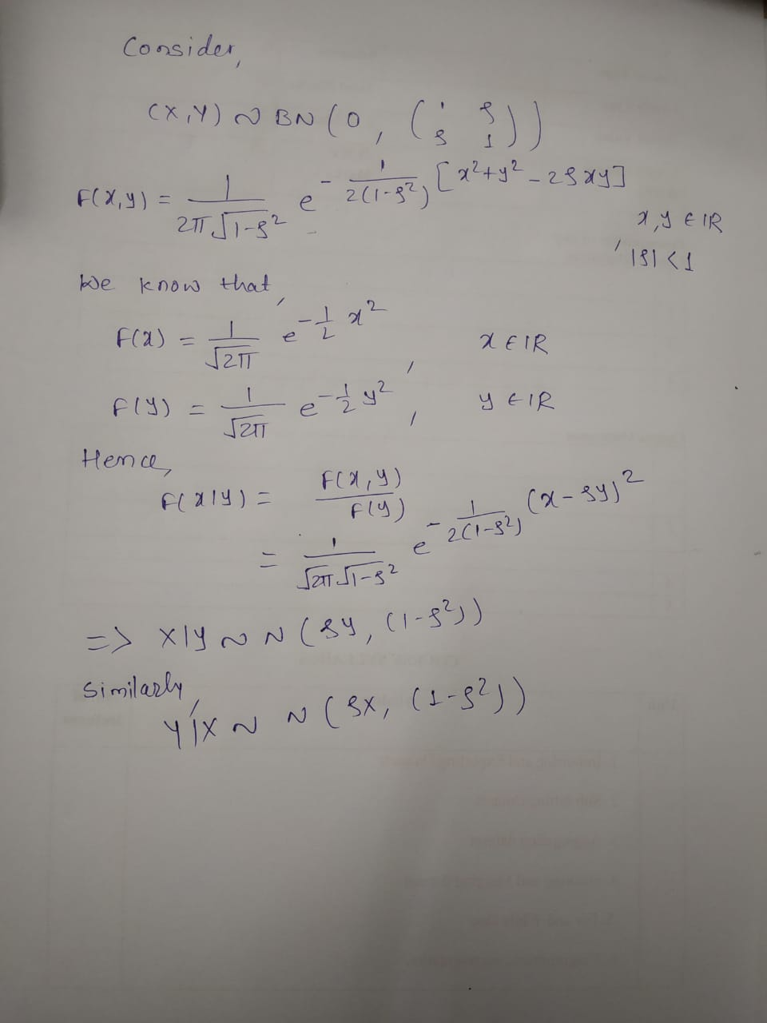

#Q3)

n=10000

rho=0.5

x=c()

y=c()

x[1]=0 # inital value

for(i in 1:n)

{

sd=sqrt(1-rho^2)

y[i]=rnorm(1,rho*x[i],sd) #sample from y|x

x[i+1]=rnorm(1,rho*y[i],sd) #sample from x|y

}

plot(density(x))

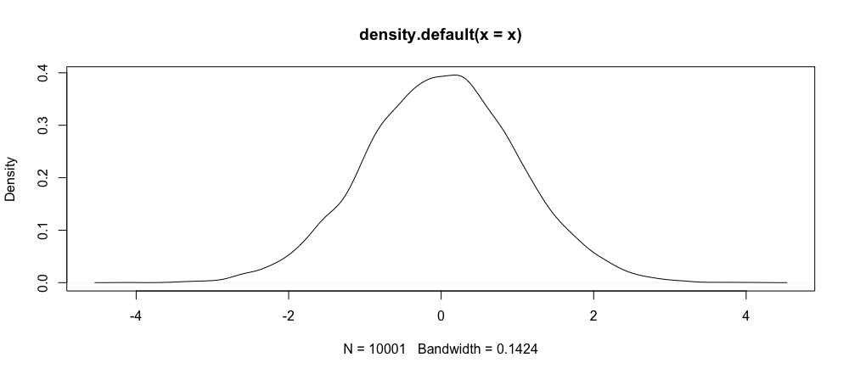

plot(density(y))

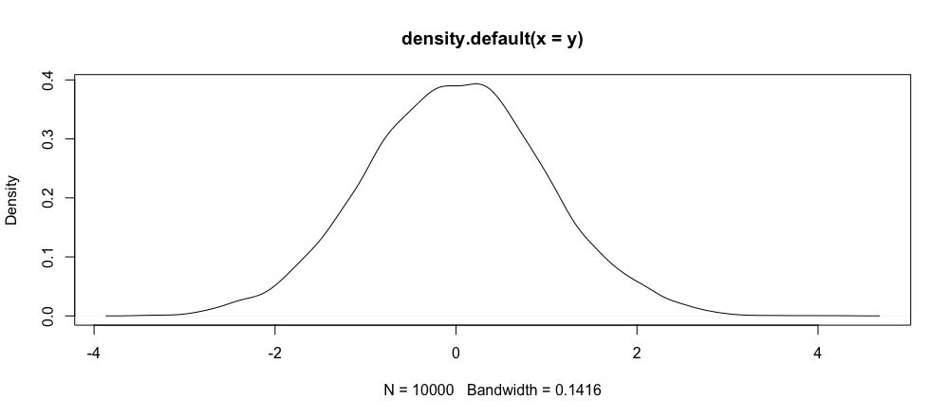

n=10000;rho=0.5

gibbs<-function (n, rho)

{

mat <- matrix(ncol = 2, nrow = n)

x <- 0

y <- 0

mat[1, ] <- c(x, y)

for (i in 2:n)

{

x <- rnorm(1, rho*y, sqrt(1 - rho^2))

y <- rnorm(1,rho*x, sqrt(1-rho^2))

mat[i, ] <- c(x, y)

}

mat

}

bvns <- gibbs(n,rho)

colnames(bvns) <- c("X1","X2")

head(bvns)

**X1 X2**

**[1,] 0.00000000 0.0000000**

**[2,] 2.53317151 0.3672901**

**[3,] -0.07435051 0.9943050**

**[4,] -0.67608714 -1.4529581**

**[5,] 0.29609972 -0.9887868**

**[6,] -0.90429491 -1.4769081**